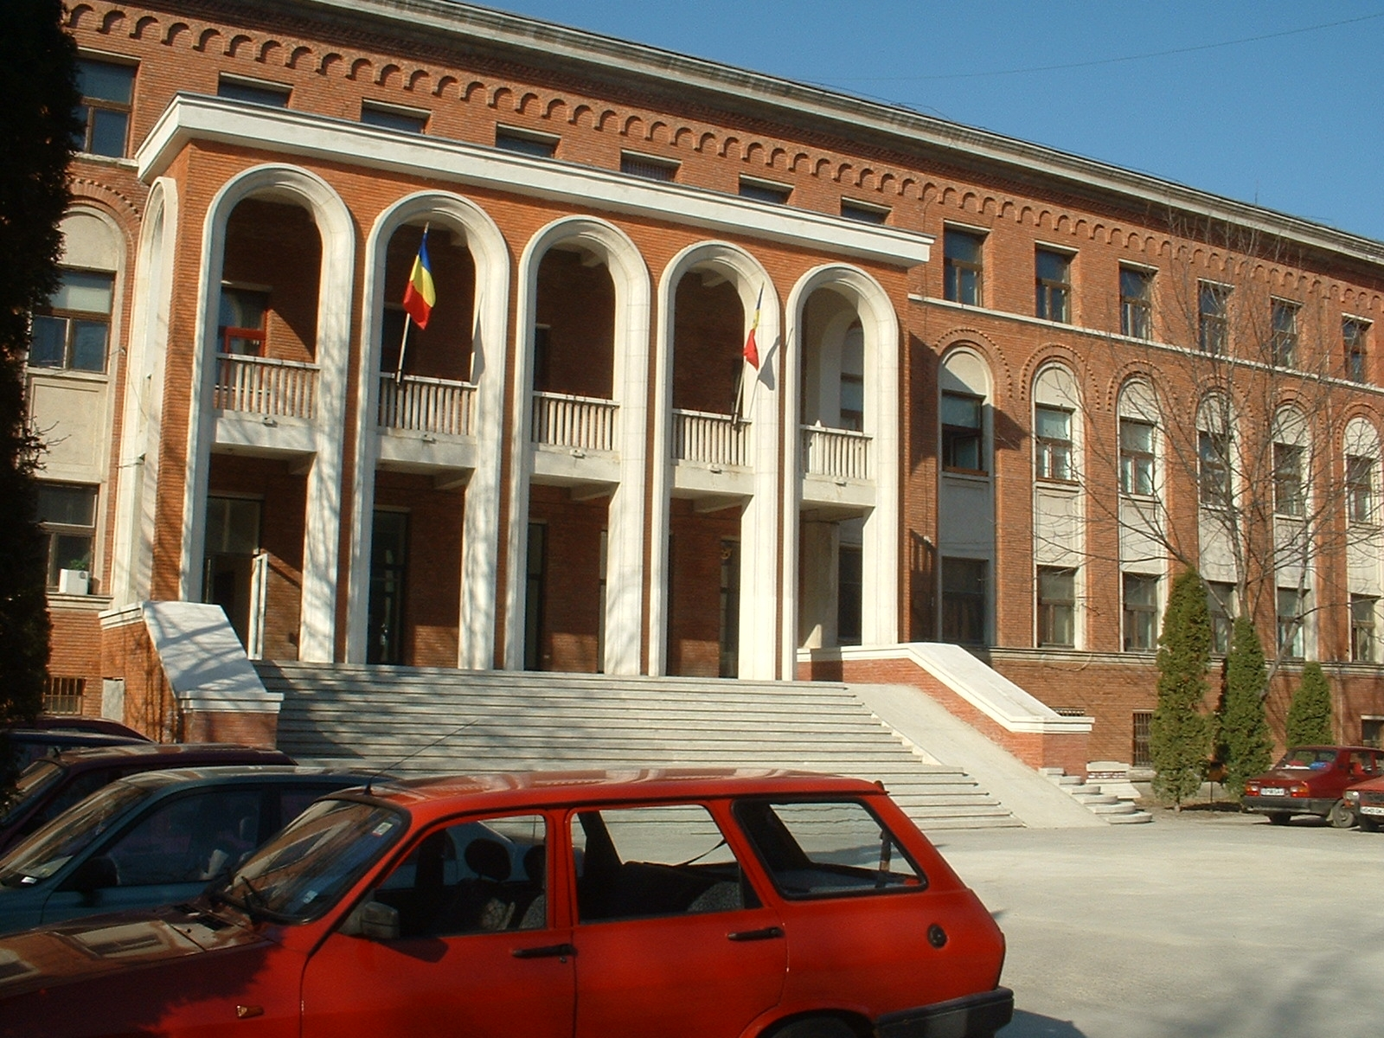 | 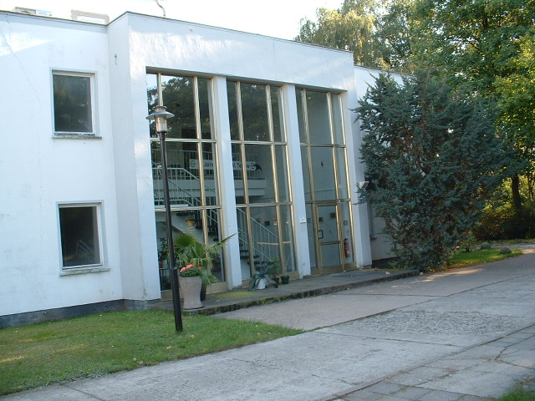

"Petru Poni" Institute of Macromolecular Chemistry  Iasi, Romania | Institute of Thin Film  Technology and Microsensorics  Teltow, Germany

3rd B i l a t e r a l S y m p o s i u m
on

FUNCTIONAL Heterocyclic and heterochain polymers

AS ADVANCED MATERIALS

September 1 - 7, 2008

Iasi, Romania

Organizing Committee:

Prof. Bogdan C. Simionescu
Dr. habil. Burkhard Schulz
Dr. Maria Bruma
Dr. Elena Hamciuc

Synthetic Program
for the entire period 1-7 September 2008
1 September :
Arrival of German participants, Accomodation in hotel.
2 and 3 September :
Symposium, Lectures and Posters in “Petru Poni” Institute of
Macromolecular Chemistry.
Visit and discussion at Faculty of Chemistry, “A. I. Cuza” University.
4 September :
Two Workshops in “Petru Poni” Institute of Macromolecular Chemistry.
5 and 6 September :
Round table with scientists from universities and managers of Chemical
Company of Iasi.
7 September :
Departure of German participants.

"Petru Poni" Institute of Macromolecular Chemistry  Iasi, Romania | Institute of Thin Film  Technology and Microsensorics  Teltow, Germany

P R O G R A M

Tuesday, September 2, Conference Hall of the Institute
9⁰⁰ – 9¹⁰ Opening: Bogdan C. Simionescu, Director of the “PetruPoni”

Institute of Macromolecular Chemistry, Iasi
Burkhard Schulz, Director of the Institute of
Thin Films Technology and Microsensorics, Teltow

L e c t u r e s

Chair persons: M. BRUMA, J. STUMPE

9¹⁰ – 9⁴⁰ | Polymer education and research in the next decades: a SWOT analysis  Bogdan C. Simionescu
9⁴⁰ – 10¹⁰ | Patterning with polymers - Functionalized materials for nano- and biotechnologies  Burkhard SCHULZ
10¹⁰ –10⁴⁰ | Advances in Polyimides  Maria BRUMA
10⁴⁰ –11¹⁰ | Supramolecular material concept for photochromism, photoorientation and light-induced mass transport  Joachim STUMPE, Y. ZAKREVSKYY, C. FAUL,  O. KULIKOVSKA, L. GOLDENBERG
11¹⁰–11⁴⁰ | Coffee
Chair persons: E. HAMCIUC, J. REICHE

11⁴⁰–12¹⁰ | Pyridine Ion Exchangers – an Alternative for the Environment  Violeta NEAGU, Cornelia LUCA
12¹⁰–12⁴⁰ | Preparation, stabilization and structure investigation of supramolecular assemblies  Jurgen REICHE, Burkhard SCHULZ
12⁴⁰–13¹⁰ | Calamitic azomethine mesogens involved in thermotropic polymers and liquid crystal composites  Vasile COZAN, Elena Gabriela Hitruc, Daniel Timpu, Magda Aflori
13¹⁰–13⁴⁰ | Electroactive polythiophene and polypyrrole derivatives for device fabrication  Hans-Detlev Gilsing, Heike Faltz
13⁴⁰–14¹⁰ | Dynamic mechanical analysis applied to the study of polyimides of various structure  Mariana Cristea, Daniela Ionita, Mariana Dana Damaceanu, Maria Bruma, Bogdan C. Simionescu
14¹⁰–15¹⁰ | Lunch break
15¹⁰–18³⁰ | Visit and discussion at Faculty of Chemistry,  “A. I. Cuza” University of Iasi

Wednesday, September 3, Conference Hall of the Institute

L e c t u r e s

Chair persons: V. COZAN, H. D. Gilsing

9⁰⁰ – 9³⁰ | Optically Induced Mass Transport Studies of azobenzene and indandione-containing films by Scanning Near-Field Optical- and Atomic Force Microscopy  B. STILLER, M. SAPHIANNIKOVA, K.MORAWETZ, J. ILNYTSKYI, D. NEHER, I. MUZIKANTE
9³⁰ –10⁰⁰ | Thin films based on thiophene derivatives for application in organic field effect transistors  Mariana Dana DAMACEANU, Maria BRUMA
10⁰⁰ –10³⁰ | Shaping of conducting polypyrrole during polymerization  Burkhard SCHULZ, Isabel DIEZ, Klaus TAUER
10³⁰ –11⁰⁰ | pH-/temperature-responsive polymeric microspheres for controlled release of drugs  Gheorghe FUNDUEANU, Marieta CONSTANTIN
11⁰⁰–11³⁰ | Coffee
Chair persons: Valeria HARABAGIU, Burkhard STILLER

11³⁰ –12⁰⁰ | Organic-Inorganic Nanocomposites for Volume Holographic Recording  J. STUMPE, O.SAKANO, L.GOLDENBERG, T. SMIRNOVA
12⁰⁰–12³⁰ | Liquid crystals for opto-electronic applications  Luminita MARIN, Silvia DESTRI, Mariana Dana DAMACEANU, Maria BRUMA
12³⁰–13⁰⁰ | Polymer hydrolytic and enzymatic fragmentation kinetics studied via the Langmuir monolayer technique  J. REICHE, A. N. KULKARNI, K. KRATZ, I. M. SOKOLOV, A. LENDLEIN
13⁰⁰–13³⁰ | Polysilane Structures for Optoelectronics  Liviu SACARESCU
13³⁰–14⁰⁰ | Recovery and reprocessing of polyvinylbutyral (PVB) interlayer from automotive windshields  Hans-Detlev GILSING, Dietrich PRESCHER
14⁰⁰–15⁰⁰ | Lunch Break
15⁰⁰ - 18⁰⁰ | Tour of the surroundings of Iasi
18⁰⁰ - 21⁰⁰ | Posters Session

Thursday, September 4, 2008
Chair persons: Oana PETREUS, Corneliu HAMCIUC

9⁰⁰ – 11³⁰ | Workshop I : New polycondensation polymers for micro-  and nanoelectronics, telecommunication etc  Department of Polycondensation
11³⁰ –12⁰⁰ | Coffee
Chair persons: Bogdan C. SIMIONESCU, Burkhard SCHULZ

12⁰⁰ –14³⁰ | Workshop II: Modern techniques, equipment and methods for investigation of Polymers and Advanced Materials  Department of Structure and Physics of Polymers
Friday and Saturday, September 5 and 6, 2008

Round table with scientists from “G. Asachi” Technical University,

“A. I. Cuza” University, and Managers of Chemical Company of Iasi (will take place in a mountain resort)

Posters

Wednesday, September 3, 18⁰⁰- 21⁰⁰ h

P1: Polyimides containing functional hydroxy groups
Elena Hamciuc¹, Maria Bruma¹, Burkhard Schulz², Marta Szesztay³
¹ “Petru Poni” Institute of Macromolecular Chemistry, Iasi-700487, Romania
² Institute for Thin Film Technology and Microsensorics, Teltow-14513, Germany
³ Chemical Research Center, Budapest H - 1525, Hungary

P2: Synthesis and properties of polyimides containing oxadiazole and naphthalene rings
R. D. Rusu¹, M. D. Damaceanu¹, M. Bruma¹, B. Schulz^{2,3}
¹ "Petru Poni" Institute of Macromolecular Chemistry, Iasi-700487, Romania
² University of Potsdam, Institute of Physics and Astronomy, Chemical Physics,
Karl-Liebknecht Str. 24-25, Golm D-14476, Germany
³ Institute for Thin Film Technology and Microsensors, Kantstraße 55, Teltow-14513, Germany

P3: Shaping of conductive polypyrole during polymerization
I. Diez¹; K.-D. Tauer²; B. Schulz³
¹ University Potsdam, Institute of Physics, Am Neuen Palais 10, Potsdam 14469, Germany
² Max-Plack-Institute of Colloids and Interfaces, Am Mühlenberg,
14476 Potsdam-Golm, Germany
³ Institute of Thin Film and Microsensoric Technology, Kantstraße 55, Teltow 14513, Germany

P4: Electrochemical behavior of some triphenylamine - based oligomers
Loredana Stafie and Mircea Grigoras
“Petru Poni” Institute of Macromolecular Chemistry, Iasi - 700487, Romania

P5: Synthesis and Characterization of Functional Textile Composites Based on Conducting Polymers
L. Cianga^{1,2}, I, Cianga^{1,2}, F. M. Tanasa¹, C. Loghin³, Y. Yagci²
¹ “Petru Poni” Institute of Macromolecular Chemistry, Iasi, Romania
² Istanbul Technical University, Department of Chemistry, Istanbul, Turkey
³ “Gheorghe Asachi” Technical University, Faculty of Textile and Leather Engineering, Iasi, Romania

P6: New hybrid materials based on aluminia compounds for photopatterning
Pattaradanai Jirasrikoonthon¹, Burkhard Schulz¹, Anja Voigt², Gabi Grützner²
¹ Universität Potsdam Am Neuen Palais 10, Potsdam 14469, Germany
² Microresist technology GmbH, Köpenicker Str. 325, Berlin 12555, Germany
P7: Functional polyimides for high performance applications
Camelia Hulubei, Elena Hamciuc, Maria Bruma
“Petru Poni” Institute of Macromolecular Chemistry, Iasi, Romania

P8: Polymer membranes for microactuators
E. Hamciuc¹, C. Hamciuc¹, I. Sava¹, C. Hulubei¹, M. Bruma¹, M. Cazacu¹,
C. Racles¹, M. Ignat², G. Zarnescu²
¹ “P. Poni” Institute of Macromolecular Chemistry, Iasi 700487, Romania
² National Institute for Research and Development in Electrical Engineering ICPE-CA, Splaiul Unirii 313, Sector 3, Bucharest 030138, Romania

P9: Polymer-LC based electrically switchable diffractive devices
J. Stumpe¹, O. Sakhno¹, S. Slussarenko²
¹ Fraunhofer Inst. for Applied Polymer Research, Geiselbergstr. 69, Potsdam D-14476, Germany
² Institute of Physics, NAS of Ukraine, pr. Nauki 46, Kiev 03022, Ukraine

P10: Discussion concerning the reliable determination of the intrinsic viscosity
C. E. Brunchi¹, S. Morariu¹, C. Hulubei¹, M. Bercea¹, B. A. Wolf²
¹″Petru Poni″ Institute of Macromolecular Chemistry, Iasi-700487, Romania
²Institut für Physikalische Chemie der Johannes Gutenberg-Universität Mainz and Materialwissenschaftliches Forschungszentrum der Universität Mainz, Welder-Weg 13, D-55099 Mainz, Germany

P11: Enzymatic degradation of polyethylene / starch blend films
R. Bodirlau, C. A. Teaca, D. Ciolacu, I. Spiridon
“Petru Poni” Institute of Macromolecular Chemistry
Aleea Gr. Ghica Voda 41A, Iasi – 700487, Romania

P12: 3D Orientation of Cinnamoyl Containing LC Polymers
R. Rosenhauer, Ch. Kempe, B. Sapich, and J. Stumpe
Fraunhofer Institute for Applied Polymer Research, Science Center Golm, Geiselberg Str. 69, Potsdam 14476, Germany

P13: Materials Based on Bismaleimide Polymers with Potential Applications
Mitica Sava
„ Petru Poni” Institute of Macromolecular Chemistry, Iasi – 700487, Romania

P14: Thermodynamic aspects concerning the solutions of random copolymers
M. Bercea^{1,2}, J. Ecklet², B . A. Wolf²
¹ ″Petru Poni″ Institute of Macromolecular Chemistry, Iasi-700487, Romania
² Institut für Physikalische Chemie der Johannes Gutenberg-Universität Mainz and Materialwissenschaftliches Forschungszentrum der Universität Mainz, Welder-Weg 13, D-55099 Mainz, Germany

P15: SNOM transmission and flouorescence measurements of polymeric nanoparticles made for organic solar cells
Burkhard Stiller¹, Thomas Kietzke¹, Katharina Landfester², Dieter Neher¹
¹ University of Potsdam, Institute of Physics, Soft Matter Physics, Am Neuen Palais 10, Potsdam 14469, Germany
² University of Ulm, Macromolecular Chemistry, Albert-Einstein-Allee 11, Ulm 89069, Germany

P16: Phosphorus-containing polysulfone. I. Synthesis and characterization
Oana Petreus, E. Avram, D. Serbezeanu
″Petru Poni″ Institute of Macromolecular Chemistry, Iasi-700487, Romania

P17: New polymers with alkylidenesuccinimide-structure based on bismaleimides and biscitraconimides
Constantin Gaina, Viorica Gaina
Institute of Macromolecular Chemistry “P. Poni”, Iasi - 700487, Romania

P18: Light induced oxidative switching of anthracene monolayers
B. Stiller¹, W. Fudiker², F. Albrecht¹, St. Katholy¹, T. Linker², D. Neher¹
¹ Universität Potsdam / Institut für Physik
² Universität Potsdam / Institut für Chemie

P19: New copoly(ether sulfon-imide) oligomers with polyelectrolyte behavior
M. Ciobanu, C. Brunchi, E. Perju, M. Bercea, V. Cozan, M. Bruma
‘Petru Poni’ Institute of Macromolecular Chemistry, Iasi 700487, Romania

P20: Bismaleimide-functionalized polyethylene as reactive modifier in complex blends with recycled polymers
R. N. Darie, C. Vasile, M. Sava
“Petru Poni” Institute of Macromolecular Chemistry, Iasi, Romaina

P21: Stimuli-sensitive statistic block-copolymer films
J. Reiche§*, A. Kulkarni, J. Hartmann$, Y. Bodenthin§, T. Acosta§, H. Kamusewitz&, H. Kosmella&, S. Kelch&, A. Lendlein&

§ Universität Potsdam, Institut für Physik, Am Neuen Palais 10, Potsdam D-14469, Germany

& GKSS Forschungszentrum Geesthacht, Institut für Chemie, Kantstrasse 55, Teltow D-14513, Germany

$ MPI for Colloid and Interface Research, Am Muehlenberg, Golm D-14, Germany

P22: Synthesis and characterization of some polyesters and poly(ester-imide)s based on bisphenol-A derivatives
Tachita Vlad-Bubulac, Corneliu Hamciuc, Oana Petreus
“Petru Poni” Institute of Macromolecular Chemistry, Iasi 700487, Romania

P23: Influence of methoxy side groups on the thermotropic behaivior of calamitic azomethinE mesogens
E. Perju, M. Ciobanu, V. Cozan, M. Bruma
‘Petru Poni’ Institute of Macromolecular Chemistry, Iasi 700487, Romania

P24: Electro-optical and morphology properties of a main chain fluorene polyrotaxanes
Aurica Farcasª, Werner M. Nau^{b}, Nathalie Jarroux^{c} , Philippe Guégan^{c}, Valeria Harabagiuª, Bogdan C. Simionescuª
ª “P. Poni” Institute of Macromolecular Chemistry, Iasi-700487, Romania
^{b} Jacobs University Bremen, School of Engineering and Science, Campus Ring 1,
Bremen D-28759, Germany
^{c} Laboratoire Matériaux Polymères aux Interfaces, Université d’Evry, France

P25: The thermal behavior of nanosilver-polyurethane composites
Emil Stoica¹ , Liana-Cătălina Ciobanu², Constantin Ciobanu¹, Leonard Ignat¹, Maurusa Ignat¹
¹ Institute of Macromolecular Chemistry "Petru Poni", Iasi, 700487, Romania
² “Al I. Cuza” University, Faculty of Physics, Iasi, 700506, Romania

P26: Phenothiazine derivatives. 1,3-dipolar cycloaddition of organic azides
Dalila Belei, Lucian Birsa, Elena Bicu
“Al. I. Cuza” University, Faculty of Chemistry, Iaşi - 700506, Romania

P27: Convenient and High-Yielding Preparations of Mono(5-carboxy-2-ethylpentyl) Phthalate and its Ring-Deuterated Isomer – The “Third” Major Metabolite of Bis(2-ethylhexyl) Phthalate
Hans-Detlev Gilsing^{*a}, Jürgen Angerer^{b}, and Dietrich Prescherª
ªInstitut für Dünnschichttechnologie und Mikrosensorik, Teltow 14513, Germany
^{b}Institut&Poliklinik für Arbeits-, Sozial-&Umweltmedizin der Friedrich-Alexander-Universität Erlangen-Nürnberg, Schillerstr. 25-29, Erlangen 91054, Germany

P28: Linear and crosslinked polysiloxanes with azobenzene chromophore in the side chain
Carmen Racles, Anton Airinei
“Petru Poni” Institute of Macromolecular Chemistry, Iasi

P29: Synthesis and properties of cyano containing polyimides based on 2,6-bis (m-aminophenoxy) benzonitrile
I. Bacosca, E. Hamciuc, M. Cristea, M. Bruma
Institute of Macromolecular Chemistry, Romania

P30: Polythiophene and polypyrrole derivatives for electrochromic applications
H.-D. Gilsing¹, H. Faltz¹, K.-H. Heckner², A. Kraft², M. Rottmann²
¹ Institute of Thin Film Technology and Microsensorics, Teltow 14513, Germany
² GESIMAT GmbH, Köpenicker Str. 325, Berlin 12555, Germany

P31: Production of high putity and specialty chemicals for the Romanian industry, hospitals and other institutions
Irina Obrocea, Geta Ciobanu, Cristian Logigan, Vasile Ciobanu
S.C. Chemical Company S.A., Bd. Chimiei no. 14, Iasi 700487, Romania

P32: Solid state properties of some strong polycation/azo dye complexes
Ionel Adrian Dinu¹, Ecaterina Stela Dragan¹, Gabriela Lisa²
¹ “Petru Poni” Institute of Macromolecular Chemistry, Iasi, Romania
² “Gh. Asachi” Technical University, Iasi, Romania

P33: Composite hydrogels based on chitosan
Maria Marinela Perju, Ecaterina Stela Dragan, Gabriela Lisa
“Petru Poni” Institute of Macromolecular Chemistry, Iasi, Romania

